> setwd("/media/user/软件/learnSpector/SDWorkshop-main")
> source("R code/07 SRBS/Garments.R")
>
> library(ggplot2)
> library(ggpubr)
> range_Adjustment_Fraction <- seq(0,1,length.out=50)
> range_Desired_Garment_Discard_Rate <- seq(0,1,length.out=50)
>
> sim_inputs <- expand.grid(range_Desired_Garment_Discard_Rate,
+ range_Adjustment_Fraction)
> summary(sim_inputs)
Var1 Var2
Min. :0.0000 Min. :0.0000
1st Qu.:0.2449 1st Qu.:0.2449
Median :0.5000 Median :0.5000
Mean :0.5000 Mean :0.5000
3rd Qu.:0.7551 3rd Qu.:0.7551
Max. :1.0000 Max. :1.0000
> run_id <- 1
>
> sim_res <- map2(sim_inputs[,1],
+ sim_inputs[,2],~{
+ res <- run_scenario(run_id = run_id,
+ Adjustment_Fraction = .x,
+ Desired_Fashion_Obsolescence_Rate = .y)
+ run_id <<- run_id + 1
+ res
+ }) %>% dplyr::bind_rows()
> sim_res
# A tibble: 1,002,500 × 16
RunID time Garments_in_Circulation Total_Discards
<int> <dbl> <dbl> <dbl>
1 1 0 100000 0
2 1 0.25 100000 22500
3 1 0.5 100000 45000
4 1 0.75 100000 67500
5 1 1 100000 90000
6 1 1.25 100000 112500
7 1 1.5 100000 135000
8 1 1.75 100000 157500
9 1 2 100000 180000
10 1 2.25 100000 202500
# ℹ 1,002,490 more rows
# ℹ 12 more variables: Fashion_Obsolescence_Rate <dbl>,
# Expected_Garments_Discards <dbl>, F1_GP <dbl>, F2_GD <dbl>,
# F3_CEGD <dbl>, F4_IID <dbl>, F5_CDR <dbl>, A1_GAT <dbl>,
# A2_DGIC <dbl>, A3_ST <dbl>, P1_DFOR <dbl>, P2_AF <dbl>
# ℹ Use `print(n = ...)` to see more rows

> p3 <- ggplot(sim_res,aes(x=time,y=Total_Discards,color=RunID,group=RunID))+
+ geom_line()+
+ scale_color_gradientn(colors=rainbow(14))+
+ theme(legend.position = "none")+
+ labs(title="Infections (flow)")+
+ theme(title = element_text(size=9))
> p3

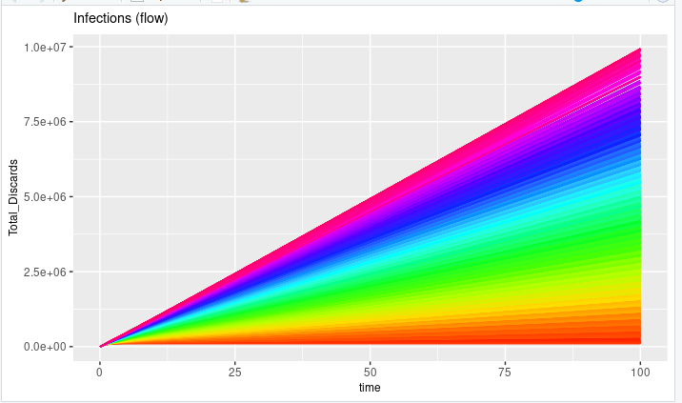

> p5 <- ggplot(time_h,aes(x=time,y=TotalDiscardsMean))+geom_line()+
+ geom_ribbon(aes(x=time,ymin=Q05,ymax=Q95),
+ alpha=0.4,fill="steelblue2")+
+ labs(title="90% quantiles for people in hospital")+
+ theme(title = element_text(size=9))
> p5

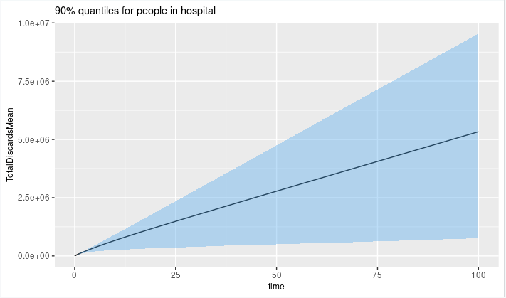

> max_TD <- sim_res %>%
+ dplyr::group_by(RunID) %>%
+ dplyr::summarize(MTD=max(Total_Discards),
+ AF=first(P2_AF),
+ DGDD=first(P1_DFOR))
> p6 <- ggplot(dplyr::sample_n(max_TD,250),aes(x=AF,y=DGDD,color=MTD,size=MTD))+geom_point()+
+ scale_color_gradient(low="blue", high="red")+
+ ylab("Desired Fashion Obsolescence Rate")+
+ xlab("Adjustment Fraction")+
+ # labs(title=paste0("Sensitivity Analysis"))+
+ theme(title = element_text(size=9))+
+ labs(colour="Maximum Total Discards",
+ size="Maximum Total Discards")
> p6

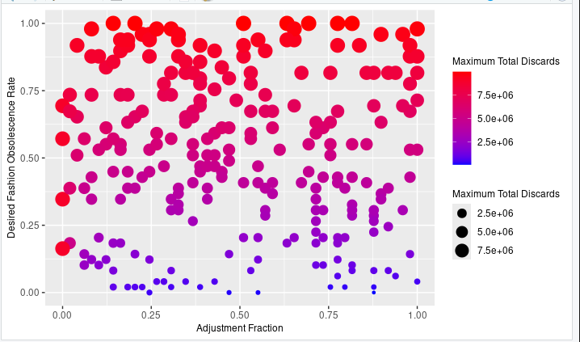

> p7 <- ggplot(max_TD,aes(x=AF,y=DGDD,z=MTD))+geom_contour_filled()+
+ ylab("Desired Fashion Obsolescence Rate")+
+ xlab("Adjustment Fraction")+
+ theme(title = element_text(size=9))
> p7

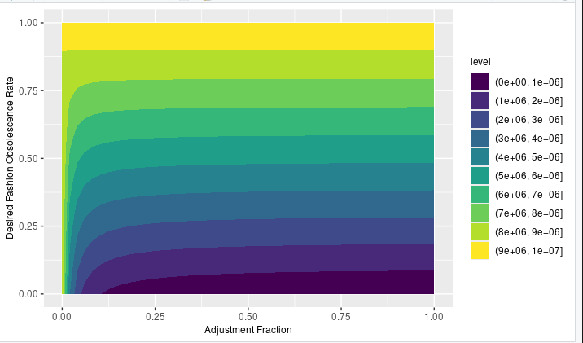

> g3 <- ggarrange(p6,p7,nrow = 1)
> g3

